2.5D Isometric Hack-N-Slash Game.

Pre-Production.

Inspiration.
polyCaves (previous student project): https://sam-cox.itch.io/polycaves
Head over Heels: https://youtu.be/Nt2nTni0z4k
Max Payne (Gameboy Advance): https://youtu.be/WOJ88WX-RWc

Programs/Languages.
Unity 2021.3.9f1, Visual Studio Code/JetBrains Rider, C#, GIMP (GNU Image Manipulation Program), GitHub Desktop/Git, Adobe Photoshop, Adobe Fresco (iPad), Microsoft Visio (web).

Platforms.
Android, iOS/iPadOS, Linux, macOS, Microsoft Windows.

Licence.
MIT Licence.

Theme.
Futuristic city at night-time.

Game goal.
Get to the end of the level.

Weapons.
Gun, sword.

Characters.
19-year-old humanoid.

Concept art.
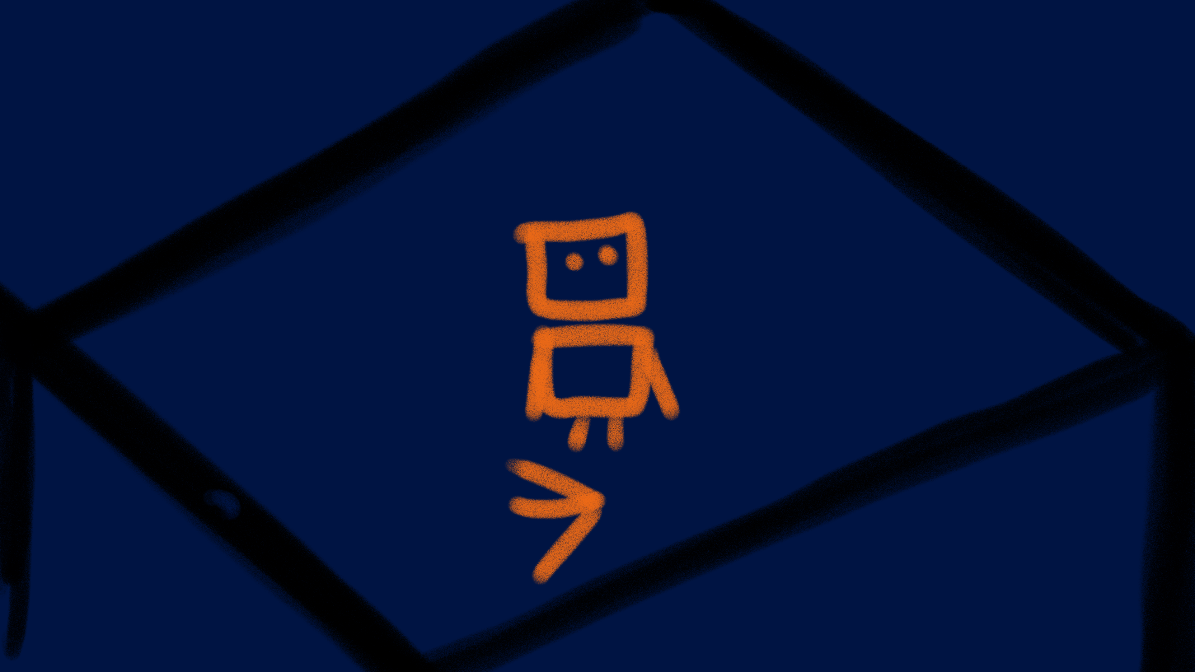

Character Design Iteration.
Marvin.
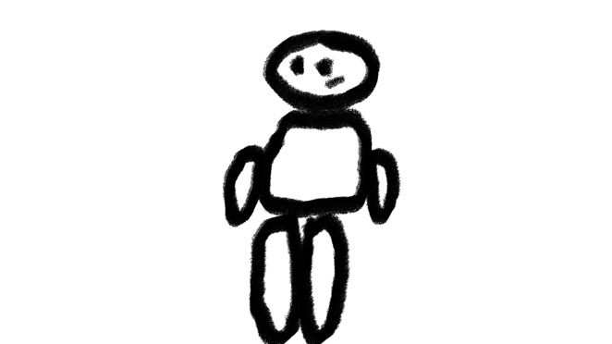
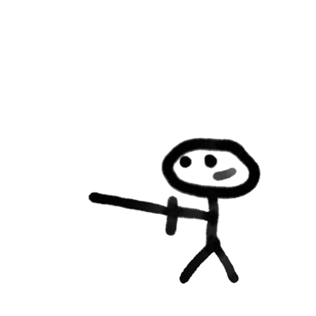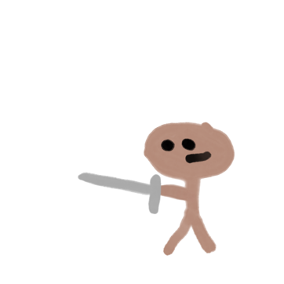

Character flowcharts.

Enemy movement.
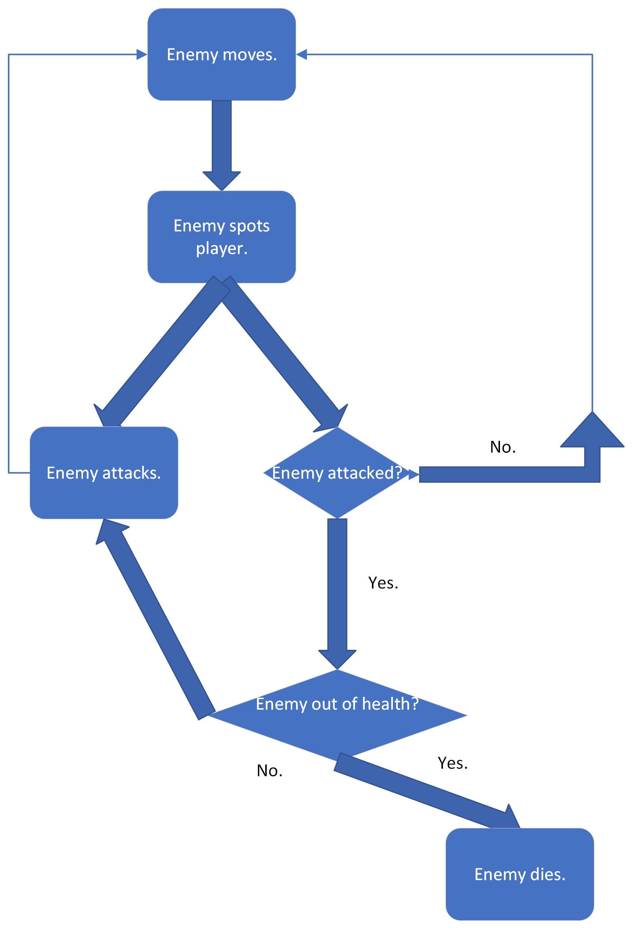

Player movement.

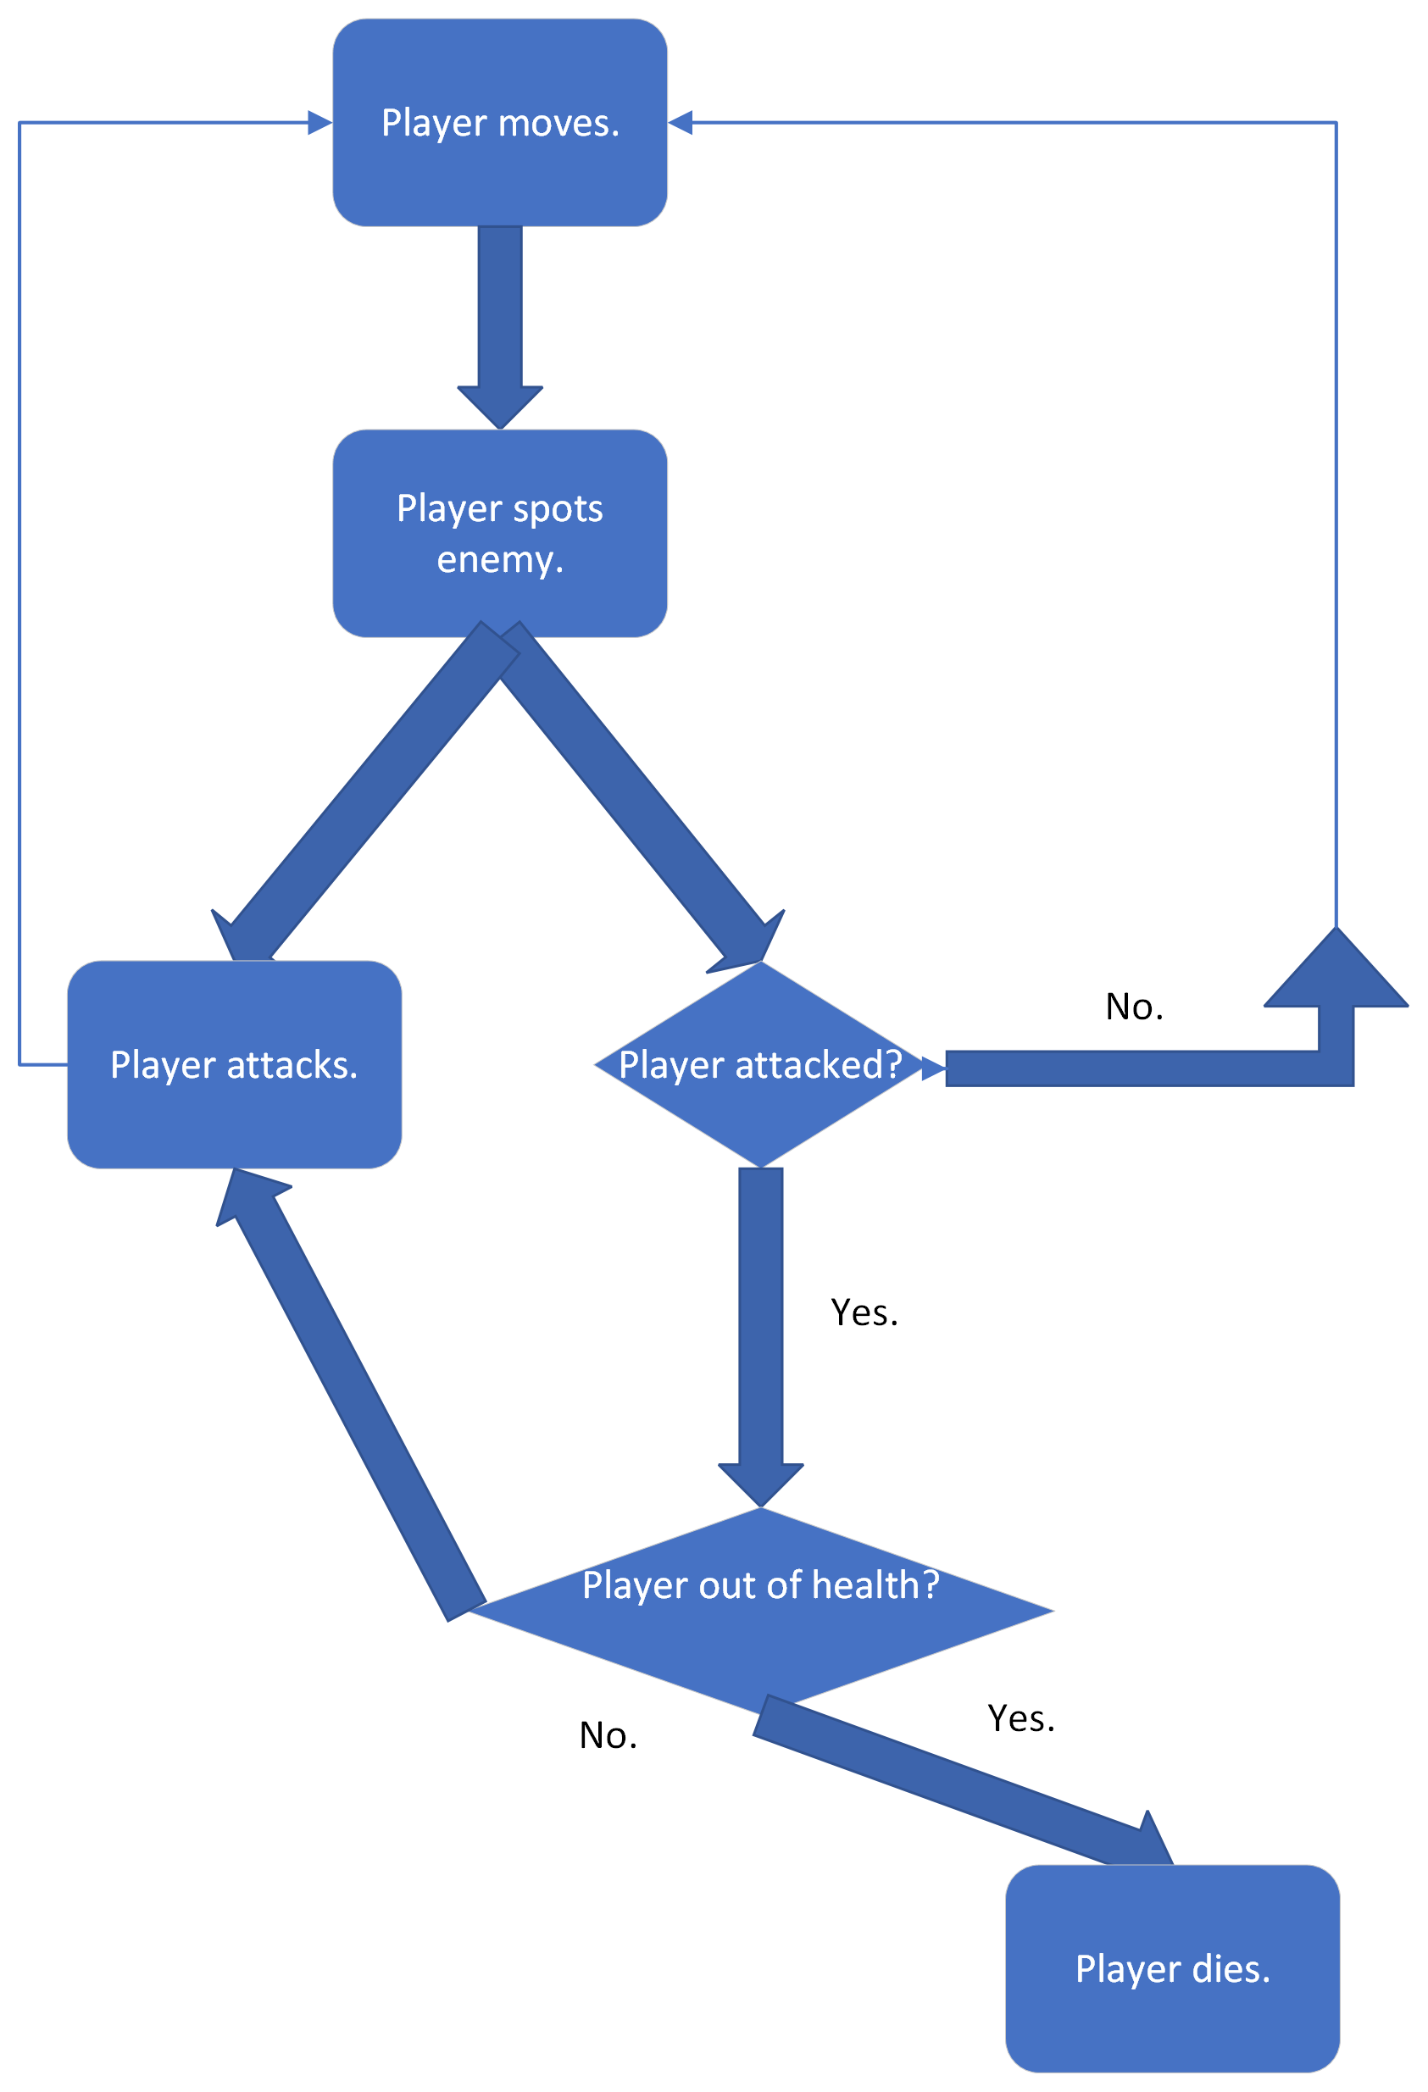

Collect health/points.
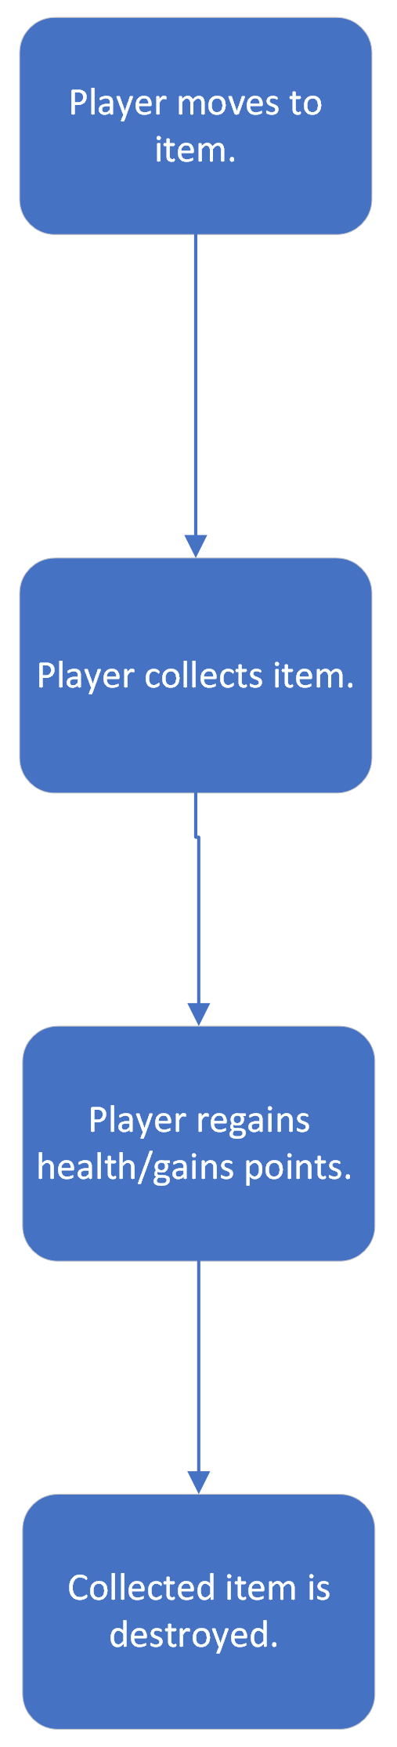

Character AI.
